SMAC 2026 — DEMO DAY POSTER CONTENT KIT
Khutwa
خُطوة
“Every step waters the story.”
Theme: AI for a Stronger Family Bonds · UAE Year of Family 2026
Team: May Ahmed Mourad (AI & Data Lead) · Shamsa Faris Al Mazrouei (Core App Lead)
github.com/MayMourad/SMAC-ADNOCMZ-Khutwa
How to use this document
Every section below is written as ready-to-paste poster copy — a headline plus short body text, matching the panel layout in your SMAC sample poster (Problem → Solution → Key Features → App Showcase → Expected Impact → Tech Stack → Team). Each panel is tagged with the SMAC scoring criterion it feeds, so nothing on the 100-point rubric is left uncovered. Trim the body text to fit your template's text boxes; the headlines can be pasted as-is.

Rubric Coverage Map
SMAC 2026 scores out of 100 across four weighted criteria. This table shows where each poster panel below earns its marks — use it to sanity-check your final poster before printing.
Criterion (weight) | Sub-criteria | Covered by panel(s) below
Idea & Theme relevance (20%) | Originality & usefulness (10%) · Relevance to theme (10%) | The Problem · The Idea · Theme Alignment
Implementation & usability (25%) | UI / user-friendliness (10%) · Functionality (15%) | App Showcase · Key Features · The Khutwa Score
Quality (20%) | Mobile app realization (10%) · Performance & reliability (10%) | App Showcase (real screenshots) · Tech Stack · Status panel
Knowledge & GitHub Check (35%) | GitHub repo & dev evidence (10%) · Q&A session (25%) | Try It / Evidence panel (QR + repo) · Responsible AI panel — Q&A itself is not poster content, but this doc's “Talking Points” section preps it

1 · Poster Header
App name
Khutwa (خُطوة) — Arabic for “step.”
Tagline
Every step waters the story.
Competition line
SMAC 2026 — Smart Mobile App Contest · Khalifa University · Theme: AI for a Stronger Family Bonds
Team credit
Developed by May Ahmed Mourad (AI & Data Lead) and Shamsa Faris Al Mazrouei (Core App Lead)
RUBRIC → sets up Relevance to Theme (10%) before a judge reads a word further

2 · The Problem
Headline
Movement and memory are fading together.
Body copy
- Families mean to spend active time together, but the time that happens keeps getting shorter.
- The everyday stories and places our elders carry go unrecorded.
- Step-count apps are individual and competitive; heritage content is static and disconnected from the family.
RUBRIC → Idea Originality & Usefulness (10%) — a real, clearly-stated problem, not a generic pitch

3 · The Solution
Headline
One family. One shared Ghaf tree.
Body copy
The Ghaf — the UAE's national tree — survives the desert by sending its roots deep and sheltering life around it: a natural symbol for a family that stays connected. Khutwa turns a family's everyday walk into a living ritual around one shared tree. Every step the family takes together waters it. The walk is the reason to be together — not the goal.
How it works (4 steps — good as a poster diagram)
- 1. A guardian creates a family and shares an invite code; 2–3 members join.
- 2. Combined daily steps grow the shared tree through six visible stages: seed → sprout → sapling → young → mature → ancient.
- 3. Walking near a curated family heritage place unlocks a short AI-narrated story about it, read aloud on the phone.
- 4. When two or more family members are physically together, the tree blooms — a small, visible, shared moment.
RUBRIC → Relevance to Theme (10%) — the app's unit is the family, not the individual; movement is the occasion for bonding, not a fitness score

4 · Key Features
- Family group & shared steps — members link into one family; step counts contribute to one shared tree
- Growing Ghaf tree widget — six illustrated growth stages tied to cumulative family movement
- 8 curated heritage stories (Abu Dhabi) — Qasr Al Hosn, Sheikh Zayed Grand Mosque, the Corniche, Heritage Village, Umm Al Emarat Park, Founder's Memorial, Al Maqta Fort, Al Bateen Dhow Yard
- Geofence-triggered narration — arriving at a site unlocks its story, read aloud via on-device text-to-speech
- “Together” bloom — the tree visibly blooms when family members are co-located
- The Khutwa Score — one 0–100 number combining movement, togetherness and heritage (see panel 6)
- Privacy-first by design — location processed on-device; nothing leaves the family group; parental control over what younger members' accounts record
- Full English & Arabic — in-app language toggle with right-to-left layout
RUBRIC → Functionality (15%) — give each bullet its own icon in the template for scan-ability

5 · App Showcase
Two real, working screens exported straight from the shipped build — use as-is, they're not mockups:
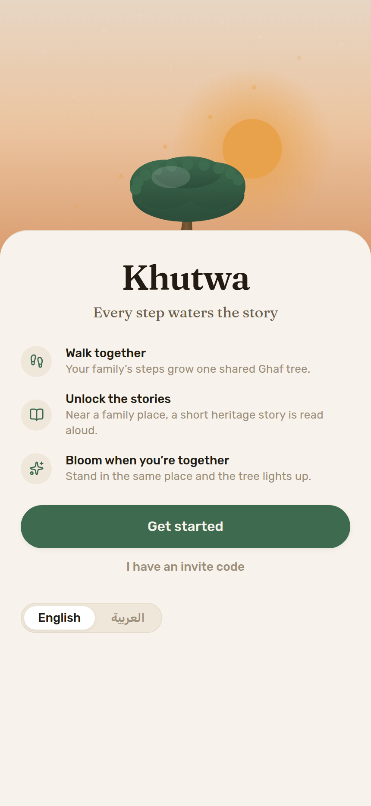  Onboarding — “Oasis” visual design | 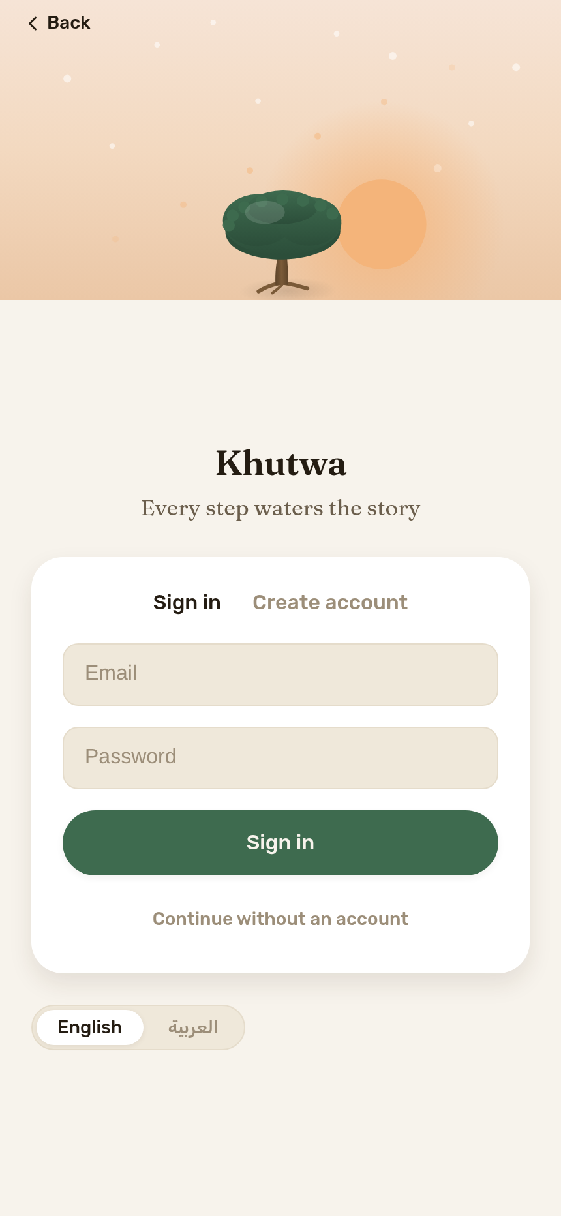  Sign in — email or guest, EN/AR toggle

Other screens to capture from a live phone before printing (need a signed-in family, so a live screenshot from the demo device beats a mock):
- Home — the shared Ghaf tree at its current growth stage + the Khutwa Score ring
- Walk — today's combined family steps, the manual-log fallback, and the “We're together” bloom button
- Stories — the list of unlocked / locked heritage stories with the narration player
- Family — member list, invite code, and each member's location-sharing toggle
Why only 2 of 6 screens are pre-rendered here
The other four screens read live family data from Firebase, so a meaningful screenshot needs an actual signed-in demo family — grab those four straight from the demo phone (the app is already seeded with 8 heritage memories, per docs/architecture.md) rather than from a cold install, so the tree, score and stories aren't empty.
RUBRIC → Mobile App Realization (10%) — real screenshots outperform mockups here; UI/user-friendliness (10%)

6 · The Khutwa Score — the app's original metric
A single 0–100 number, recomputed weekly from real activity, built from three weighted sub-scores. This is Khutwa's most defensible “originality” talking point in the Q&A — it's a designed model, not a raw step count.
Sub-score | What it measures | Weight in final score
Root | Family movement: combined steps, active minutes, co-movement sessions | 40%
Bloom | Togetherness: memory unlocks, story contributions, together-moments | 35%
Heritage | Culture: distinct heritage sites visited, stories preserved | 25%

Bonding + culture (60%) deliberately outweigh raw fitness (40%) — movement is the occasion, not the goal.
Growth stages
seed (0–9) → sprout (10–24) → sapling (25–44) → young (45–64) → mature (65–84) → ancient (85–100). Early stages come fast to encourage new families; “ancient” is deliberately hard to reach.
RUBRIC → Idea Originality (10%) and Functionality (15%) — a transparent, explainable scoring model the team can walk a judge through line by line

7 · Tech Stack
Layer | Technology
Framework | React Native + Expo (SDK 57), TypeScript, expo-router (file-based navigation)
UI / motion | react-native-svg, react-native-reanimated, expo-linear-gradient, @expo-google-fonts (Rubik + Fraunces)
Sensors | expo-sensors (steps) · expo-location (geofencing) · expo-speech (on-device text-to-speech)
Backend | Firebase Authentication + Cloud Firestore (region me-central1, Doha)
AI | Cloud LLM (Claude) — used only during development to pre-generate cached, reviewed heritage narrations
Build & distribution | EAS Build — installable Android APK (no store); iOS via Expo Go for judging
RUBRIC → Performance & Reliability (10%) — shows a real cross-platform, cloud-backed stack, not a prototype

8 · Responsible, Narrow AI — and Privacy
Headline
AI has one job: turn a place and a family's memory into a short, warm spoken story.
- Every story is generated ahead of time from approved public heritage content, reviewed by the team, then cached on the phone — the shipped app makes no live AI calls.
- A member's real-time location is never sent to any AI service or third party; it stays on-device and inside the family group.
- Claude (via Claude Code) was used as a development assistant — scaffolding, the Firebase/service layer, the scoring logic, and UI build-out — with every session logged (prompts + outcome) in docs/ai-prompt-log.md, per the competition's AI-disclosure rule.
- The team did not use AI to originate the concept, the scoring model, or the choice of heritage sites — and can explain every file in the codebase.
RUBRIC → Knowledge and GitHub Check (35%) — judges will check this; the full prompt log and AI-usage report already live in the repo (docs/AI-USAGE-REPORT.md, docs/ai-prompt-log.md)

9 · Alignment with Theme & UAE Year of Family 2026
- Family Bonds theme: the app's unit is the family, not the individual — AI deepens a shared experience instead of automating it away.
- UAE Year of Family 2026: turns a daily habit into something a family keeps, together.
- Cultural grounding: the Ghaf tree (UAE national tree) as the central metaphor; 8 real Abu Dhabi heritage sites carry the story content.
- Accessibility: full English/Arabic bilingual support with right-to-left layout, so grandparents and children can use it equally.
RUBRIC → Relevance to Theme (10%)

10 · Expected Impact
- A consistent, low-friction reason for families to walk together instead of separately.
- Heritage stories that would otherwise stay oral get written, reviewed, and passed to the next generation through the app.
- A shared, visible measure (the Khutwa Score / tree stage) that makes family togetherness legible without turning it into a competition between members.
- A bilingual design that includes grandparents, not just tech-comfortable family members.

11 · Try It — Evidence Panel (QR codes)
Put these two side-by-side in a corner panel — judges scan the left for the code, the right for the app itself.
  Scan for the GitHub repo (code, commits, dev evidence) |   Scan to download & install the Android app (free, no account)

Links (for the small print)
GitHub: github.com/MayMourad/SMAC-ADNOCMZ-Khutwa
Android APK: expo.dev/artifacts/eas/P_Z82Z_LLAEUqIJWAqzjOWPk2WpwMH_p9vwUXzoJOnI.apk
iOS / any device: Expo Go app → run ‘npx expo start --tunnel’ from the repo → scan the QR it prints
RUBRIC → GitHub Repository & Development Evidence (10%) — put the repo one scan away from every judge

12 · Team & Closing
Name | Role | GitHub
May Ahmed Mourad | AI & Data Lead — story generation pipeline, scoring model, Firebase, bilingual layer | MayMourad
Shamsa Faris Al Mazrouei | Core App Lead — navigation, screens, location service, UI | sfarismaz

Khutwa — every step waters the story.

Appendix · Q&A Talking Points (35% of the score — not poster copy, but prep for it)
This isn't poster text — it's for the team to rehearse, since Q&A is worth more than every visual panel combined.
Be ready to explain, from memory, without notes:
- How the Khutwa Score is computed (the exact weights: Root 40% / Bloom 35% / Heritage 25%, and why bonding+culture outweigh raw steps).
- Where AI was used vs. not — story pre-generation (a feature) vs. Claude-as-coding-assistant (development only) — and that no LLM call happens at runtime.
- The Firestore data model: families / steps / stats / treeState / memories, and why memberUids is kept as a flat mirror array.
- What's still stubbed: Arabic story text not yet written, generate-stories.ts's callModel() is a stub, recomputeTree runs client-side (would move server-side in production), Android historical steps returns null (manual entry fallback).
- Why location never touches an AI service or leaves the family group — walk through location.ts and the Firestore security rules live if asked.

Source material for this document: README.md, DOWNLOAD.md, LINKS.md, and docs/app-overview.md, idea-brief.md, khutwa-score.md, architecture.md, data-model.md, AI-USAGE-REPORT.md, video-assets.md, locations — all read directly from the SMAC-ADNOCMZ-Khutwa repository on 12 Sept 2026, plus the SMAC 2026 Orientation Day rubric.

